**CS397 Group 5**

**Project Assignment**

|  |  |  |  |
| --- | --- | --- | --- |
| **DigiPen Student ID** | **SIT Student ID** | **Student Full Name** | **DigiPen Email** |
| 390005919 | 1900642 | Tiong Jun Ming Jerome | j.tiong@digipen.edu |
| 440005819 | 1900858 | Derek Gan Chee Chin | c.gan@digipen.edu |
| 440000119 | 1900806 | Goh Wei Zhe | weizhe.goh@digipen.edu |

**Project Objective** **3**

**Project Description** **3**

**Diagram of Implemented System** **3**

**Block Diagrams** **4**

**Conclusion** **6**

# 

# Project Objective

The objective of the project is to implement a meaningful embedded system using previously taught assignments demonstrating the acquired embedded knowledge throughout the whole module.

# Project Description

The embedded systems project utilizes both the TM4C123G Tiva Launchpad and Nucleo-F767ZI to implement transfer of data/message from the TM4C123G board via CAN to the Nucleo-F767ZI board.

# Diagram of Implemented System

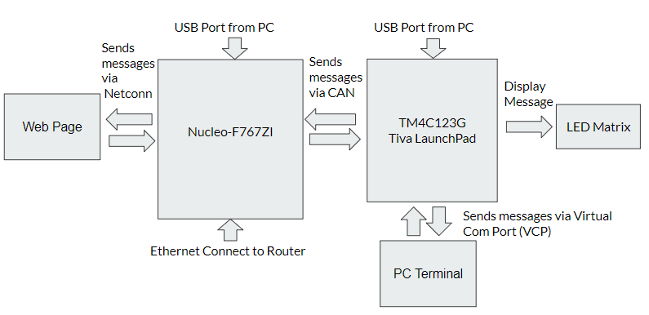

The system implemented consist of Web Page, Nucleo-F767ZI board, TM4C123G Tiva LaunchPad, PC Terminal and LED Matrix interacting with one another. The Nucleo-F767ZI has an USB input connected to the PC device at the top of the board and an Ethernet cable connected to the router at the bottom of the board. The TM4C123G Tiva LaunchPad also has a USB input connected to the PC device from the top and it is connected to Nucleo-F767ZI and the LED Matrix.

The system implemented allows our web page to communicate with the TM4C123G Tiva LaunchPad and display the message onto the LED Matrix via Nucleo-F767ZI. Firstly, the Web Page sends the messages via Netconn to the Nucleo-f767ZI board. Then, it transmits the message from the Nucleo-f767ZI board to the TM4C123G Tiva LaunchPad via Controlled Area Network (CAN). Lastly, the TM4C123G Tiva LaunchPad sends messages via Virtual Com Port (VCP) to the PC terminal and display messages onto the LED Matrix.

Vice Versa, it also allows the PC Terminal to communicate with the TM4C123G Tiva LaunchPad and display the information onto the LED Matrix and updates the message on the website via Nucleo-F767ZI. TM4C123G Tiva LaunchPad can receive messages via Virtual Com Port (VCP) from the PC Terminal and display the message onto the LED Matrix. Then, The TM4C123G Tiva LaunchPad can to transmit message via Controlled Area Network (CAN) to the Nucleo-f767ZI board. Lastly, The Nucleo-f767ZI board can send message to the Web Page via Netconn to display the message information on the website.

# Block Diagrams

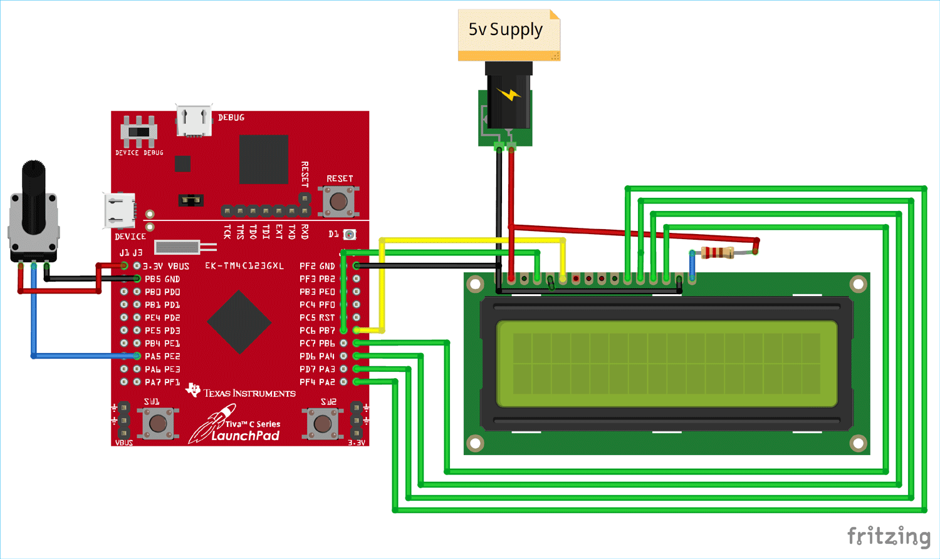

*Figure 1. Simulated Diagram of Tiva Launchpad Setup*

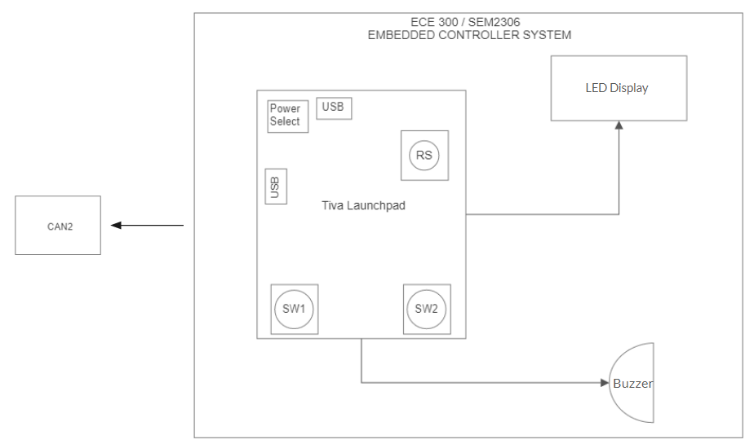

*Figure 2. Tiva Launchpad Block Diagram.*

The Tiva LaunchPad would be connected to the LED Display for the display of LED Matrix and the buzzer for additional sound properties. It would also be connected to the CAN2 receiver in order to receive and send data to the Nucleo board.

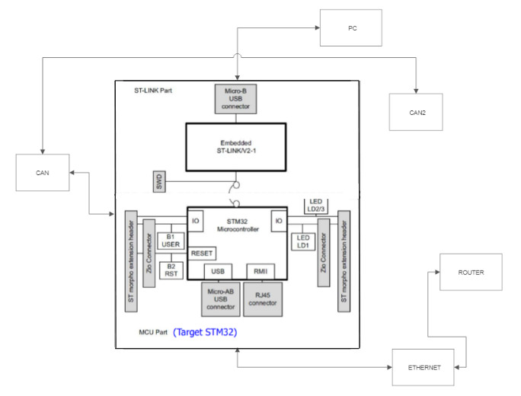

*Figure 3. Nucleo board Block Diagram*

The Nucleo board would be connected to the PC via a Micro-B USB connector, and connected to the router via an Ethernet cable. It would also be connected to both CAN1 and CAN2 receivers where CAN2 would also connect to the Tiva Launchpad.

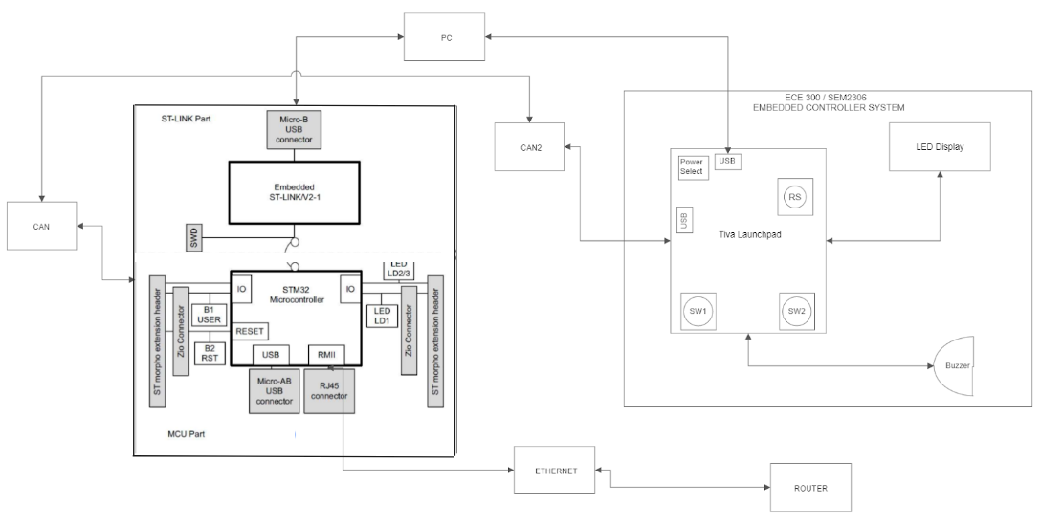

*Figure 4. Full Block Diagram*

In this block diagram, the previous two block diagrams of both the Nucleo board and Tiva Launchpad is connected together as a full block diagram set up with the fully implemented system.

# Conclusion

Configuring the Nucleo board was much easier than configuring the Tiva Launchpad on the programming side. HTML configuration took some time to configure as there were plenty of issues when first setting up the HTML page. Embedded systems can be used in many different fields as it has a broad number of usages in our current society.

# 